

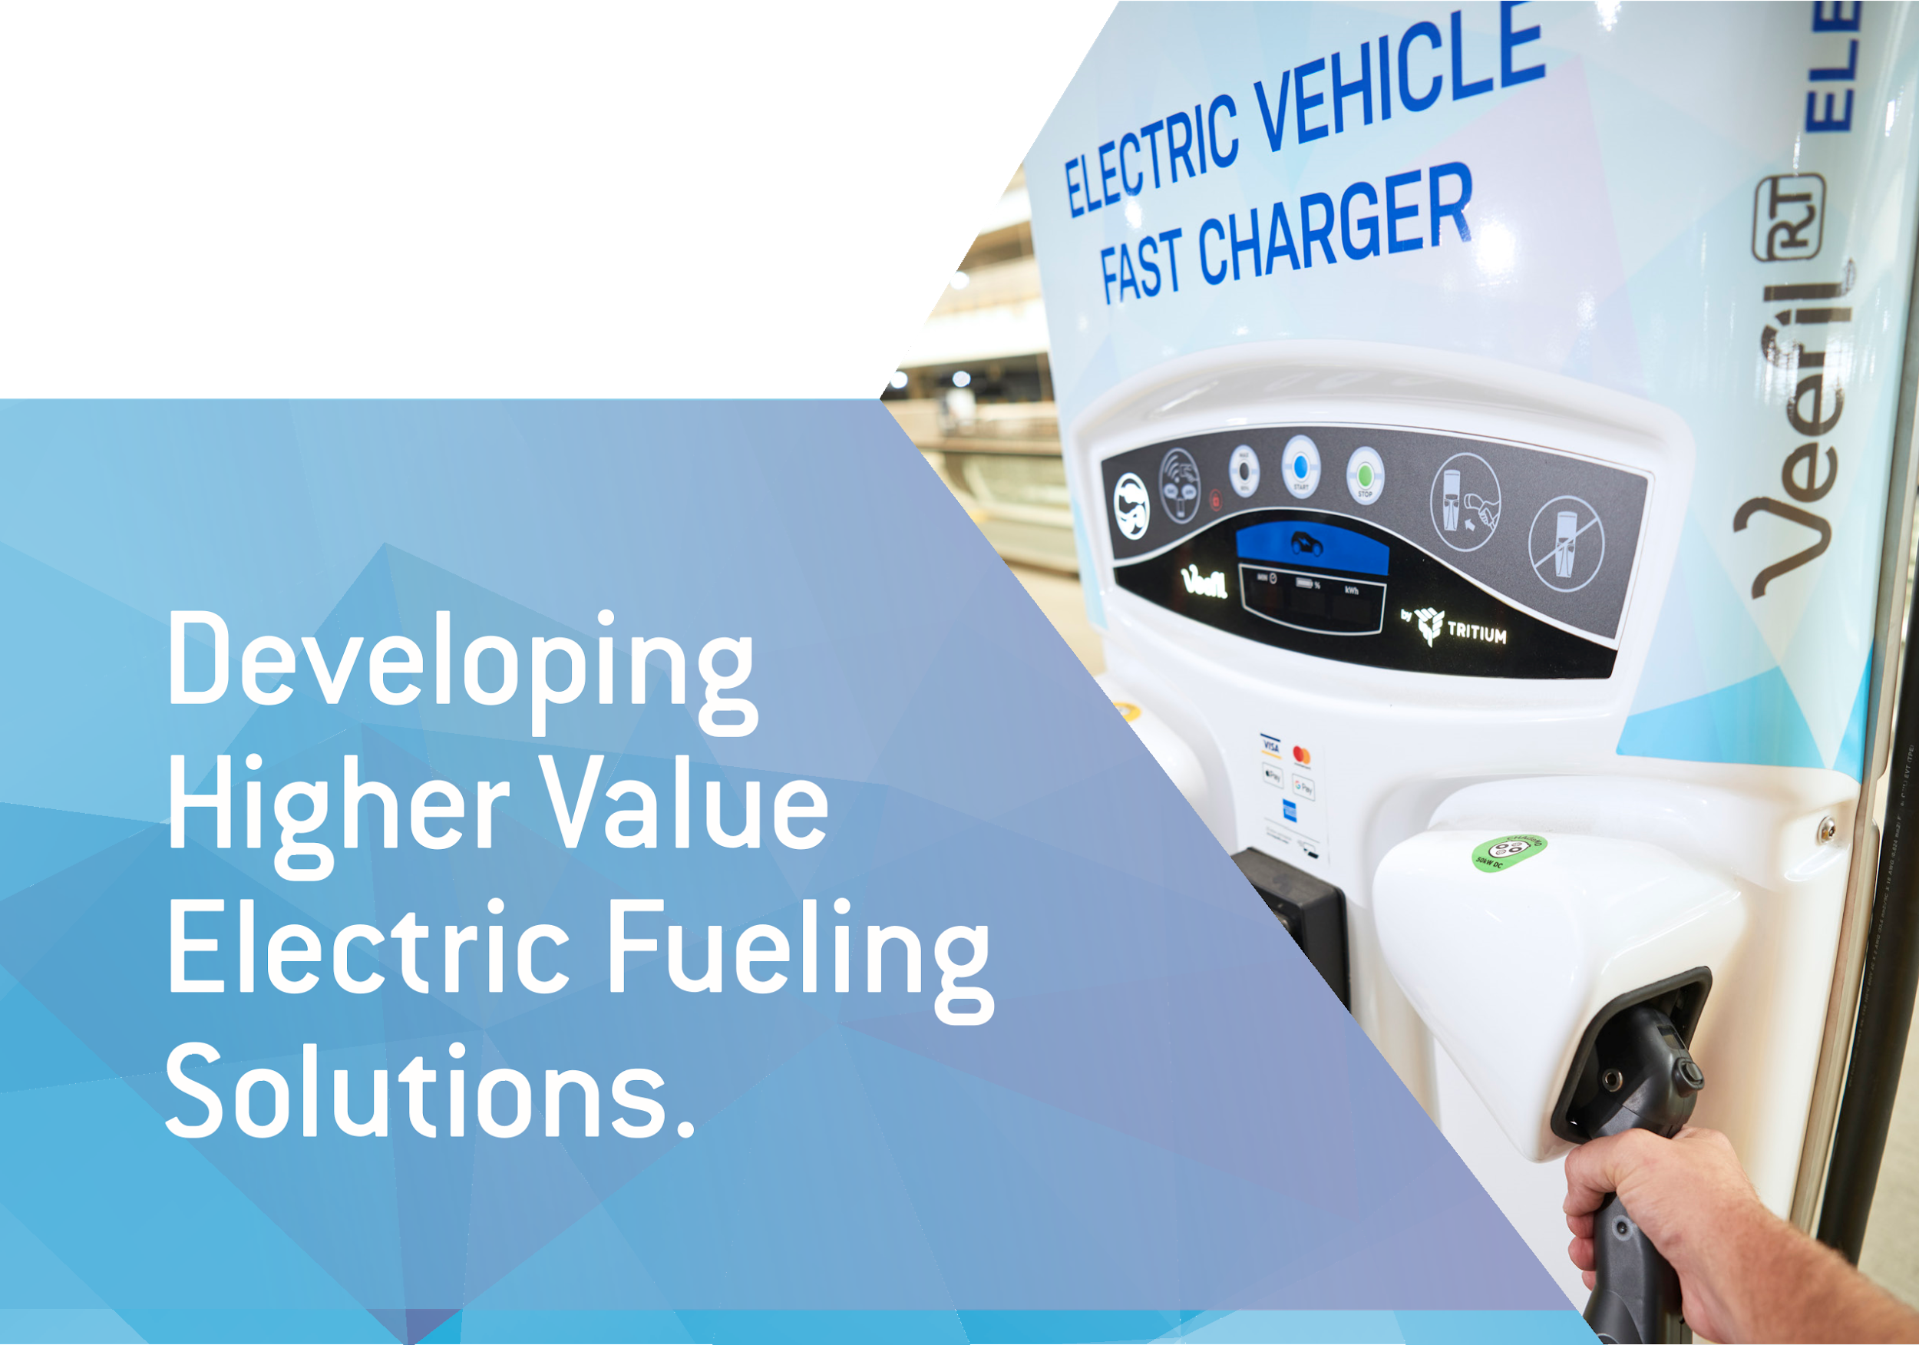
<Insert Proposal Name Here>
Request for Information
EV Charging Options

Submitted by <Insert Company Name Here>
<Insert Date HereMonth XX, 2023
Applicant Information

Company Name
Corporate Headquarters
Address
Number
website

FEIN Number: XXXXXXX (if applicable)

Please contact Contact Name & Title regarding any proposal related questions. For contract negotiations, please contact Contact Name & Title

Primary Contact
Name | Title
Email
Number

Secondary Contact
Name | Title
Email
Number

TABLE OF CONTENTS
Section 1 | Charging Equipment 4
I. Level 2 Charging Equipment 4
Figure. ZEFNET Level 2 Charging Options 4
A. ZEFNET Standard Series 5
B. ZEFNET PRO Series 5
C. ZEFNET Power Series (DC Fast Charging Options) 6
All-In-One DCFC Products 6
Cabinet + Satellite DCFC Products 6
Moveable DCFC Products 7
II. Warranty 7

Section 2 | Service Level Agreement Offerings 8
I. Proactive Equipment Monitoring & Support 9
II. Issue Identification & Dispatch 10
Scenario 1: When equipment is failing to deliver a charge. 10
Scenario 2: When error message flagged, but equipment is operating. 11

Section 3 | Network Software Functionality 11
I. Continuous Operations Supported 12
II. Network Roaming 12
A. Outline of Certifications & Integrations 13
III. ZEFNET Software 14
Figure: Primary ZEFNET Modules 15
A. Device Grouping 15
B. Load Management & Power Sharing Capabilities 15
C. Driver Fees & Price Schedules 16
Figure: ZEFNET Time-Based Rate Scheduling Capabilities (example) 17
D. Performance & Error Resolution 17
IV. Data Reporting 18
Figure: Available Charging Data (via ZEFNET) 18
V. Maximum Data Accessibility 19

Section 4 | Payment to Station Owners & Driver Fee Setting 20
I. Driver Payment Options 20
II. Driver Payment Experience 20
III. Compensation / Remittance Process 23

EQUIPMENT & WARRANTY

Section 1 | Charging Equipment

Level 2 Charging Equipment
Below is a table summarizing ZEF Energy’s commercial Level 2 charging hardware options. Both product series outlined are made in the U.S. and are Buy America compliant by default or as a product option. ZEF’s Level 2 charging options are smart, 2-way communicating hardware with firmware and communications engineered for the most reliable connectivity, granular metering, and reliable data collection on the market. This hardware, as well as our DC fast charging options are connected through ZEF Energy’s own proprietary network and load management backend software, ZEFNET.

All ZEF Level 2 charging equipment offer 4 different communications paths: cellular, wifi, ethernet, and bluetooth. We rely first and foremost on our cellular connectivity as a first communications pathway. Via cellular ZEF is connected across five (5) cellular networks: Verizon, ATT, T-mobile, Sprint and US Cellular. ZEF has first tier contracts with each of these carriers and manages cellular connectivity on behalf of our customers to give them the best user experience and strongest uptime. Additionally, our chargers are programmed with autofailover features so that each charger can move between cellular networks if connectivity is inconsistent or weak. For data resilience purposes, we also supply store and forward capabilities so that data can be held locally for over 110 days if/when connectivity is lost. This ensures that billing, submetering, and data collection can occur without interruption.

ZEFNET Level 2 Charging Options
Model Series | Power & Current | Install Options | Unique Features | Applicability
ZEFNET Standard Series | 7.7kW (40A), 11.5kW (60A), or 15.4kW (80A), or 19.2kW (100A) | Wall or pedestal mounted | 5-Year parts warranty, rugged plug design, brandable | Multi-use housing, fleet, workplace (all commercial interior or exterior applications)
ZEFNET PRO Series | 7.7kW (40A), 11.5kW (60A), or 15.4kW (80A) per plug | Dual plug pedestal only | Credit Card + RFID reader + HMI/Screen option, integrated cable management, brandable | Public charging, multiple parallel user-type sites (all commercial interior or exterior applications)
*See attached cut sheets for more detailed information.

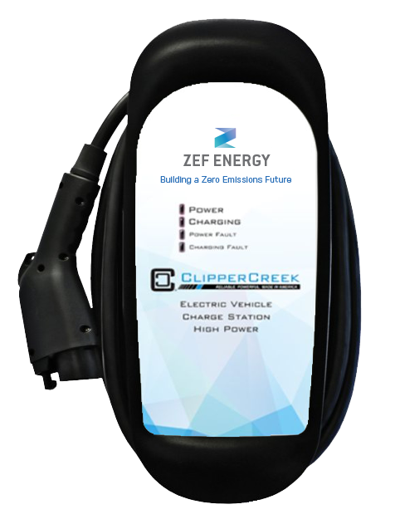
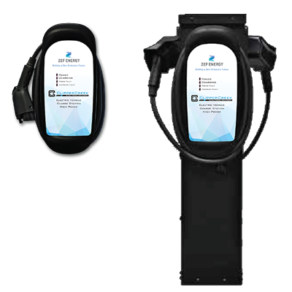
ZEFNET Standard Series

The ZEFNET Standard Series is our base Level 2 product line. This hardware is available for wall mount or can be mounted to ZEF pedestals as single or double plug pedestal chargers. The enclosure is made from high durability polycarbonate, with overmolded rubber plugs (versus plastic) plugs for resistance to cracking or breaking from impact and pressure. This product comes 23’ cords (standard) with wrap cord management allowing cords and plugs to be kept off the ground. Each charger is available for white labeling with complete customizable branding and artwork.

If a project/site requires driver authorization ahead of use, such as via payment or other acknowledgement, drivers are able to do so via the ZEFNET Charge app or one of the other networks and apps that ZEF has roaming agreements with (OCPI). The driver can authorize through a PIN or through requested access via email. Other public users can pay for charge via the app as well and the station or portfolio owners have the ability to change authorizations and cost of charge at any time.

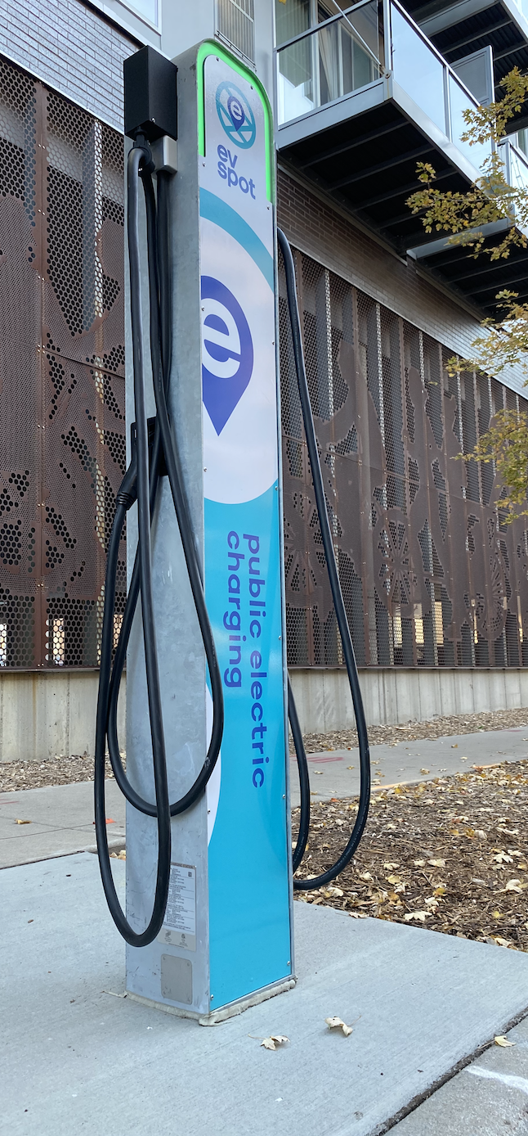
ZEFNET PRO Series

The ZEFNET PRO is our flashship hardware for public and visible fleet charging. This line offers a number of unique features compared to competing chargers on the market. The exterior enclosure is hot-dipped galvanized steel (also available in stainless steel) and has an integrated cable management system to keep plugs off the ground. The cords are 21’ long and come with the same durable, overmolded rubber plugs as is available in the Standard Series. It also offers redundant communication capabilities between the two chargers, so there are built in equipment and communication redundancies. Each unit comes pre-assembled for quick installation and lower on-site labor costs.

The unit is 6’-10” tall with LED halo indicators for each of the plugs so that drivers can see from a distance if the charger is in use or available (as well as other statuses). Each unit can be ordered with or without the Human Machine Interface (HMI), which includes a full-color touch screen, four buttons, a credit card reader and RFID reader with integrated NFC payment capabilities (i.e. Apple Pay and Google Pay). The screen offers configurable messaging and can support messaging in multiple languages. Full product white labeling is an option with a completely customizable look both front and back (13 SF of branding area in total).

II. ZEFNET Power Series (DCFCs)

ZEFNET has integrations with three (3) different DC fast charger OEMs and has the flexibility to provide over 100 different DCFC hardware products. ZEF offers three primary categories of DCFC hardware options:

- All-in-one charging units
- Cabinet + Satellite(s)
- Moveable Chargers

All of our DCFC product offerings are Build America, Buy America compliant. Some options meet the full-scope of these BABA requirements today (under the NEVI waiver) while others will meet them by Q1 2024 ahead of the end of the waiver period.
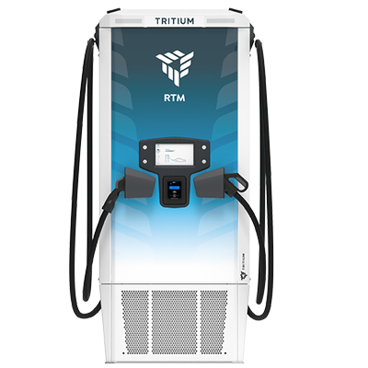
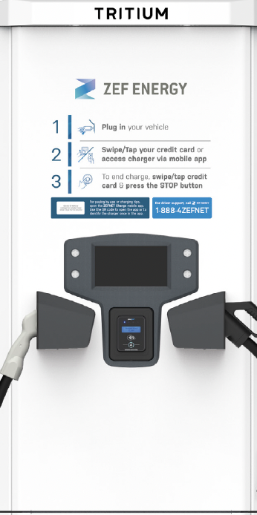

All-In-One DCFC Products
- These units offer a variety of footprint options, from small to moderate in size. Due to the compactness of having only one piece of equipment, these often offer a cost-effective price point.
- We offer DCFC products that allow for service entry from the bottom, side, or back for flexible installation in existing conditions.
- All of our commercial hardware comes with a 5-year standard warranty, with the option to purchase a 7-year or 10-year warranty up front.
- ZEF’s all-in-one products include modular and non-modular options, where an additional 25kW, 50kW or up to 350kW of additional power can be added after installation.
- We have high voltage (up to 1,000V) options as well as ‘adaptive voltage’ options, which means the equipment can offer 400V or up to 1,000V simultaneously, at plugs side-by-side.

Cabinet + Satellite DCFC Products
Our cabinet + satellite equipment options are all modular in design. This allows for multiple benefits:
- Incremental Sizing: Charging stations can be increased in increments of 50kW and each 50kW power module can split charge at the 25kW level. Charger sizing ranges from 50kW to 600kW.
- Incremental Plug Count: Plug pedestals (“dispensers) are separate from the power cabinets. Each system (power cabinet(s) + dispenser(s)) can include up to 8 plugs with any combination of CCS and CHAdeMO.
- Serviceability: Modular architecture has just five (5) components. Thus, field service technicians arrive on-site with all (5) components and perform a swap-out instead of servicing the existing equipment which has dozens of working parts, many of which are not stocked.

With the cabinet + satellite equipment we offer a wide array of power, from 50kW up to 600kW with a single cabinet (single, double, or triple cabinets, each with a capacity of up to 200kW). All of this equipment also comes with ‘adaptive voltage’, delivering at 400V or 1,000V simultaneously from one power cabinet. This is perfect for sites that might be serving light-duty as well as medium and or heavy duty vehicles now or in the future.
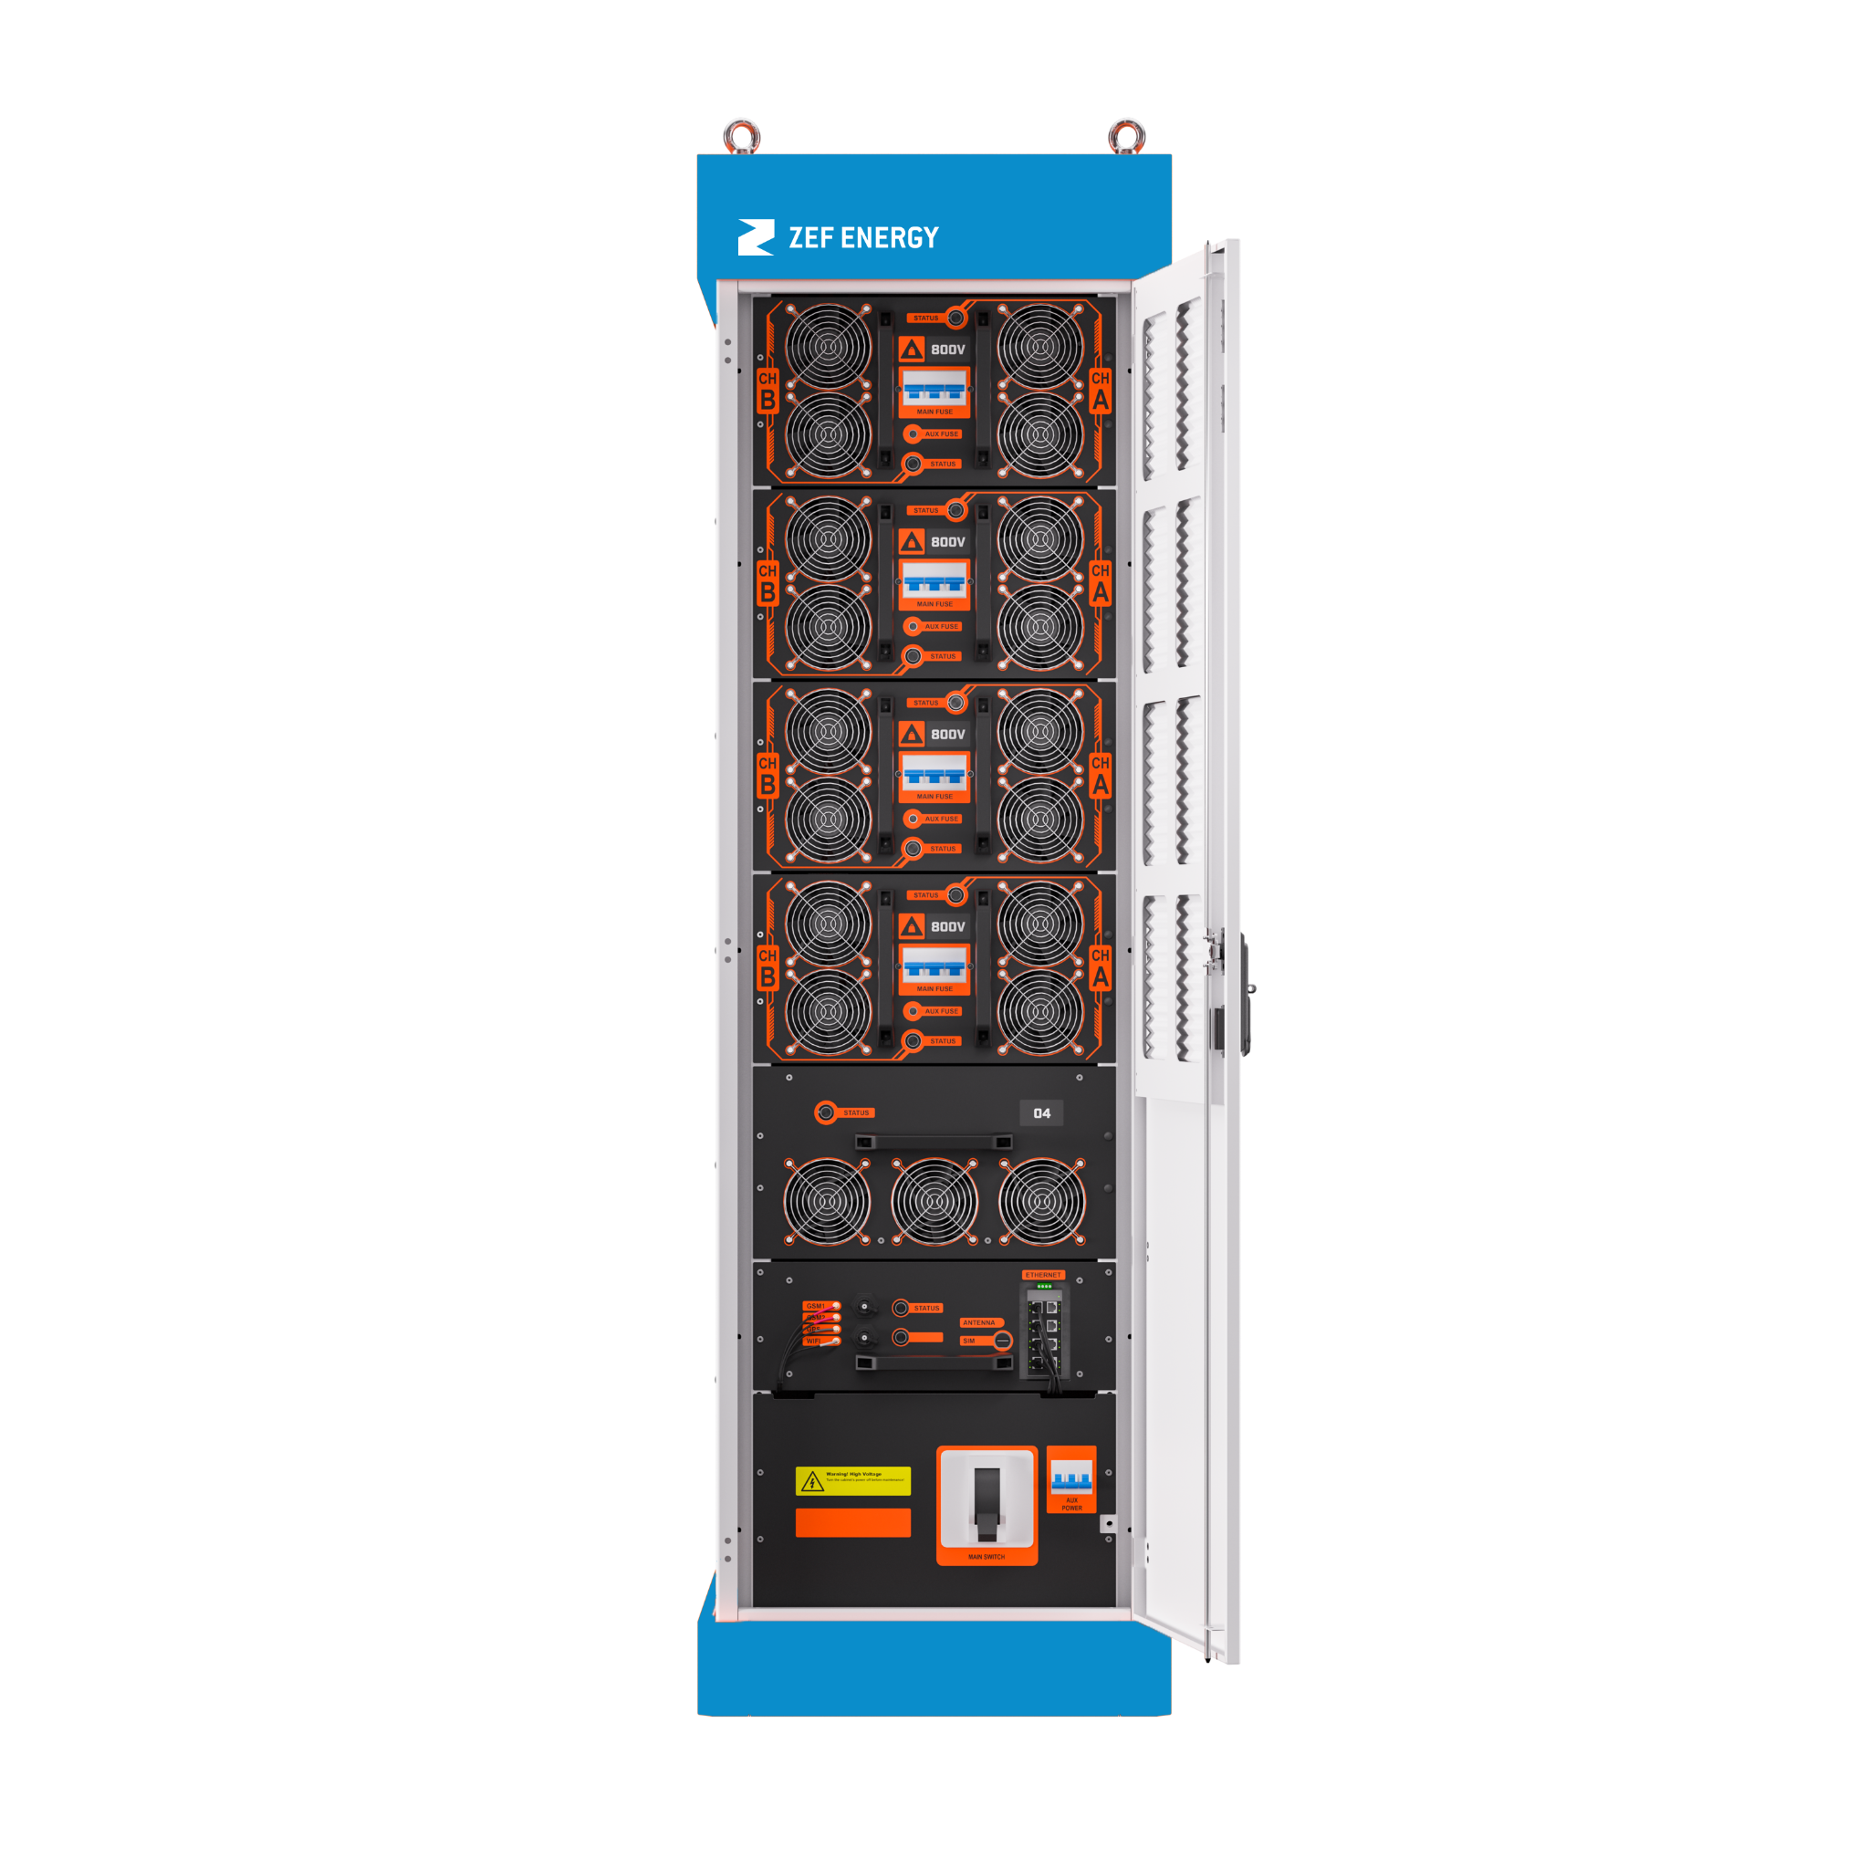
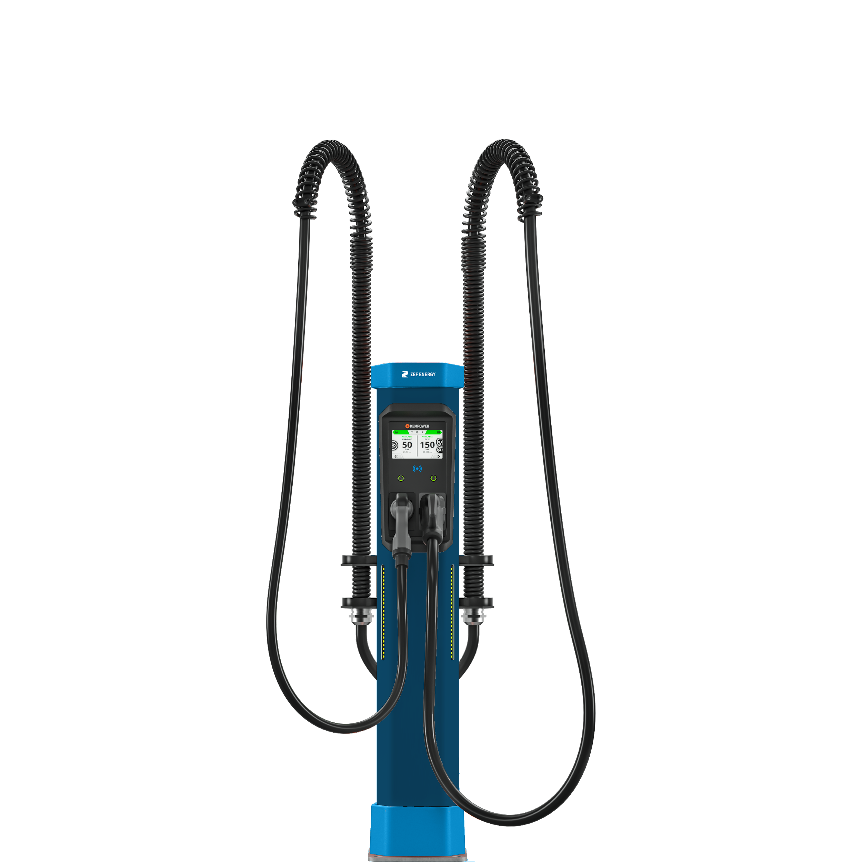
Dynamic power distribution is another benefit of this equipment. It is designed to optimize use of power capacity at all times through instantaneous redistribution of power based on each vehicle's ability to receive a charge.

  - Responds to Slower Top-Off Charging
  - Responds to Busy Station Use
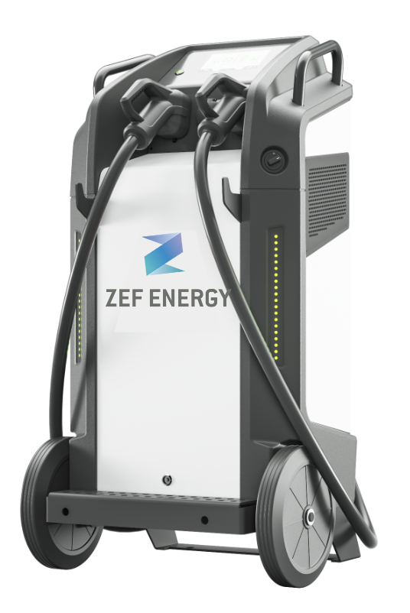

Moveable DCFC Products
ZEF Energy’s moveable charger product is excellent for fleet and service applications. It is 50kW on wheels available with one or two plugs (CCS or CHAdeMO). This often is a great supplemental equipment option for sites that have limited space options and need to get to vehicles in harder to reach areas. This product also can be significantly cheaper to install with no need for concrete mounting pads.

II. Warranty
ZEF Energy’s standard warranty offering is the best available in the market today. We offer a 5-year parts and labor warranty as standard with all of its commercial products, both DC fast charging and Level 2 equipment. Per the terms of that warranty, replacement parts will be provided under this agreement at no additional cost. For our Level 2 hardware, a warranty of up to 10 years can be purchased up front. For our DCFC equipment, options of 7 or 10 years warranty are available for most products.

ZEF Energy is committed to offering a high-value solution.
ZEF Energy’s 5-Year Advantages™ bundles all standard services costs within the upfront price. The 5-Year Advantage™ includes a 5-year parts and labor warranty, along with 5-years of cellular connectivity, 5-years of network operations, and 5-years of technical support for drivers and station owners.


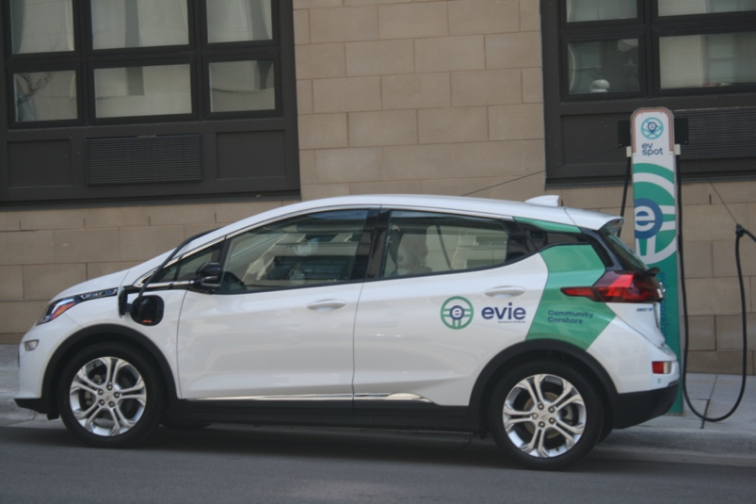

Spot Network & Evie Car Share
ZEFNET Capabilities Demonstrated

ZEF Energy partnered with the Cities of Saint Paul, Minneapolis, HOURCAR (car-share company), and Xcel Energy to deploy a 296-plug charging hub network across the two cities. This project had a number of unique requirements, which ZEF Energy has supported, from new customization options around parking fee set-up and special events, integration with municipal parking systems, as well as messaging for drivers on charger screens, and reciepts for drivers paying via the app.
The ZEFNET Connect module with in the ZEFNET back-end system allows for this complex network of partners to share data within their organizations while also selecting nuanced ways in which some data can be shared with other partners. This pertains to billing reports, network and field performance information, support tickets, and more.

SERVICE, COMMISSIONING & UPTIME

Section 2 | Service Level Agreement Offerings

In addition to our standard warranty offering of 5-years, as part of our 5-Year Advantage, ZEF Energy offers a number of Service Level Agreements through their Service Plus program. These service level agreements include annual preventative maintenance along with site-visit coverage for equipment failures that are covered under warranty (i.e. this does not include vandalism or the effects of extreme weather). The following table highlights the available Service Level Agreements via ZEF.

Service Level Agreement Options | Standard Series  (1 Year SLA) | Pro Series  (1 Year SLA) | DC Fast Chargers  (5 Year SLAs)
 | Tier 1 SLA | Tier 2 SLA | Tier 3 SLA | Tier 4 SLA
Performance Benchmark |  | 95% Uptime | 95% Uptime | 98% Uptime
Remote monitoring | ✓ | ✓ | ✓ | ✓
On-site troubleshooting | ✓ | ✓ | ✓ | ✓
Annual Preventative Maintenance (per OEM specs) |  | ✓ | ✓ | ✓
72-hour on-site response once field service need is identified | ✓ | ✓
48-hour on-site response once field service need is identified |  |  | ✓
24-hour on-site response once field service need is identified |  |  |  | ✓
Regional Stocking of spare parts |  | ✓ | ✓
Spare parts held locally (Typ. with local service partner) |  |  |  | ✓

Proactive Equipment Monitoring & Support
ZEF actively monitors all chargers in the field, tracking a number of metrics to identify potential charger issues ahead of failure. Data is collected and monitored automatically by the ZEFNET backend, on a daily and monthly basis, to flag possible issues. As an issue is flagged, it is assigned a level of urgency (Low, Moderate or Critical) and it is turned over to the ZEF Support Team for further diagnosis. The following data is collected and automatically generated in ZEFNET for all Kempower DC fast chargers in the field.
Actively Monitored Data Points:
- Error code generation
- Cellular connectivity status – current status and time since last connection
- Network (Cloud) Connectivity – current status and time since last connection
- Main Switch active – powered-up status
- Cellular signal strength and variation – can monitor when cellular network changes might be needed or antennas added
- Power derating per expected power output (power profiles)
- Internal enclosure temperature readings
- Zero length (short duration) sessions
- Number of remote restarts requested over time
- Comments from drivers on Plug Share for all sites
- In-app driver reporting monitoring (in development; to launch Q2/Q3 2023)
- Entered data or metadata (from site & equipment inspection visits):
  - Charger exterior cleanliness
  - Power module cleanliness & date of last swap out
  - Filter cleanliness & date of last swap out
  - Plug & latch condition
  - Screen condition rating
  - Credit card reader usability rating

Issue Identification & Dispatch
When a ZEF Service Level Agreement is purchased, all relevant equipment is tagged with a Service Level Agreement ID number. This ID number identifies key factors about the quality of service to be delivered to this site, including in-field response time, the proximity of the ZEF Service Pro Partner, and proximity of spare parts to the identified service partner (i.e. on-site, local, regional). Performance metrics are then tracked per each unique SLA ID number regarding in-field response time and uptime. There are multiple scenarios that can occur where corrective actions are needed. A summary of the process and timeframe to notify/dispatch for corrective actions as issues arise is included below. Note, this list is not all-inclusive.

Scenario 1: When equipment is failing to deliver a charge.
a. When a DCFC is failing to deliver a charge, and it is determined that this is due to the failure of a part that is still under warranty, the ZEF Support Team will escalate the issue and complete the process of dispatching a work order to a locally designated ZEF Service Pro Network Partner within 24-48 hours. If this equipment has an SLA, the promised in-field response time (24-hours for a Tier 4 SLA) will be honored and communicated to the Service Pro Network Partner per every work order. This site visit will be covered by the SLA and the cost of the replacement part will be covered per the terms of the warranty. *Response time is measured from the time the work is confirmed as delivered to the Service Pro Partner to the time that they arrive on site.
b. When a DCFC is failing to deliver a charge, but the issue cannot be tied to a failing part that is still under resolution (e.g. because of vandalism), a work order will be dispatched to the local ZEF Service Pro Partner. If this equipment has an SLA, the promised in-field response time (24-hours for a Tier 4 SLA) will be honored and communicated to the Service Pro Partner per every work order. However, the labor cost (per a negotiated rate between ZEF and the Service Pro Partner) and the cost of any parts not covered under warranty will be incurred by the station owner.
The greatest barrier to successfully fixing failing equipment promptly is lack of access to spare parts. Under the Tier 4 SLA, spare parts will be held locally - in most cases held by the Service Pro Partner directly. This is a unique aspect of ZEF’s service offerings. With this, most station issues will be fixed within the promised response time. This approach allows ZEF to ensure high uptime and the intended uptime associated with the Tier 4 Service Level Agreement.

Scenario 2: When error messages or issues are flagged, but equipment is still delivering a charge.
When a DCFC is still delivering a charge successfully but is showing an error message or a driver comment regarding challenges with the DCFC equipment, a ticket will be generated automatically (same day) and the ZEF Support team will evaluate the issue. A resolution to the issue will be provided per this ticket within 24-72 hours (minus holidays) of the ticket being created. Ticketing history is visible to the station owner via the ZEFNET backend portal.

NETWORK, LOAD MANAGEMENT & DRIVER APP CAPABILITIES

Section 3 | Network Software Functionality

ZEF Energy operates its own backend software platform. This network/platform is called ZEFNET and is OCPP 1.6 and OpenADR compliant. ZEFNET hosts over 5,000 charging stations and provides station owners ongoing access to charging station session data, pricing controls, performance data, and permissions setting, as well as many other features. Fundamentally, the ZEFNET software was designed for utility users, to offer the most detailed pricing/billing creation tools, reporting tools, metering integrations, and load management tools. Because of ZEF’s mission to support beneficial EV load growth, all ZEF customers have ownership of their charging session data from day one (in perpetuity). This is provided at no extra cost and is part of ZEF’s standard offering, as we wish to help utilities learn from their projects and programs.
ZEF operates chargers it sells and services on its own network. However, as an OCPP 1.6 compliant software, MLGW would have the option in the future to switch to another OCPP compliant network if that suited their needs better. This would be available to them after the end of the 5th year.

Below is a short overview of the functionalities of the ZEFNET networking software:

- Dashboard with visualized data around charging and load profile trends visualizations Set driver pricing (including taxes and fees)
- Permissions settings and partner data sharing (controlled by station owner/admin)
- Settings around dynamic power sharing across plugs
- Load management and load balancing *typically not relevant for DC fast charging
- Connectivity performance
- Charger ticketing, maintenance history, and uptime performance

Continuous Operations Supported
From a continuous operations standpoint, ZEFNET has extremely high network connectivity metrics. As a default, ZEF sets-up all chargers to fail-over into “free vend” mode (unless asked not to do so). This allows drivers to get a charge, even if an equipment issue is not yet resolved. Separately, the ZEFNET Charge App (one option for payment) has a “wallet” system. This requires that $5 be loaded on the phone ahead of starting a charge to ensure that a driver doesn’t walk away without starting a charging session. Further, if cell coverage is lost during a charging session, a driver can finish their transaction after the charging session has ended once they have regained connectivity.

Network Roaming
From a roaming and best practices perspective, ZEFNET has roaming across over 15 other networks and this will continue to expand. Currently ZEF chargers appear on the apps and maps of these other networks. In spring of 2023, ZEF will also be making the chargers from other network operators visible on the
ZEFNET Charge App. Key networks that ZEF chargers have “roaming” with include: ChargePoint, Shell Recharge, SemaConnect, Mercedes, Electric Circuit, and others.
It is important to note that the roaming efforts within the industry continues to be plagued by certain challenges, which requires two sides/operators to agree to terms of what OCPI modules they want to implement together, and then a one-time, significant effort needs to take place, to implement the roaming agreement.
It is ZEFNET’s intention to accelerate additional roaming agreements as quickly as possible, but there is no way to know how long additional agreements will take to implement, and the willingness of others to want to roam on the ZEFNET network.

Outline of Certifications & Integrations
Requirement | How Compliant
OCPP Compliant Network | ZEFNET is an OCPP 1.6 compliant allowing the customer to have the option of a different network operator in the future, if needed
OpenADR Compliant (not required) | Exceed Requirements: ZEFNET is OpenADR compliant, designed using this open protocol to allow for the most flexibility and integration with other software platforms.
Continuous Operations (even when no network connectivity) | ZEFNET has extremely high network connectivity metrics. Additionally, ZEF Energy sets-up all chargers in “free vend” mode unless asked not to. This allows drivers to get a charge while at the charger. For charger connectivity this would be rare.  Separately, the ZEFNET Charge App (one option for payment) has a “wallet” system. This requires that $5 be loaded on the phone ahead of starting a charge to ensure that a driver doesn’t walk away without starting a charging session. Further, if cell coverage is lost during a charging session, a driver can finish their transaction after the charging session has ended once they have regained connectivity.
Network Roaming | ZEFNET has roaming across over 12 other networks and this will continue to expand. Currently ZEF chargers appear on the apps and maps of these other networks. In spring of 2023, ZEF Energy will also be making these chargers (from other network operators) visible on the ZEFNET Charge App as well. Key networks included in our “roaming” network are: ChargeHub, ChargePoint, Mercedes, and others.
98% Uptime | ZEF Energy’s Service Plus Tier 4 SLA ensures that 98% uptime is measured and delivered. Response times requested by the end customer (MLGW) will be matched with a local ZEF Service Pro that is contracted to get on-site within 24-hours of the field request. Further, unique to ZEF, for sites that have our Tier 4 SLA, we stock parts with our Service Pro Partners so that they can make a ‘fix on the first visit’.
Proactive Charger/Network Health Monitoring | ZEFNET tracks multiple charger-health stats in real-time to monitor abnormal charger behavior to inform proactive remote restarts or on-site visits ahead of failure. These data points also allow us to have the best view into when a charger is down ahead of a driver pulling up. Measurements include:  - Network (Cloud) Connectivity – time since last connection  - Cellular Connectivity – time since last connection  - Credit Card Reader Connectivity – time since last connection  - Main Switch active – powered-up status  - Plug Status – all plugs in active status  - Internal cabinet or unit temperature – operating within a healthy temperature range (i.e. filters are clean)  - Metadata with photographic validation of all historic on-site visits and scheduled maintenance

ZEFNET Software
Our operational software, ZEFNET, is a one-stop shop for both DCFC and L2 chargers as it pertains to:
- Data acquisition and reporting
- EV driver support ticketing and dispatch
- Remote diagnosis of faults, remote restarting, and firmware updates
- Load management and data feed integration (solar PV, battery storage, anything with an energy monitor upon it)
- Driver access, price setting, and point-of-sale authorization (e.g. take credit card payments)
- Controls configurable messaging to drivers via the ZEFNET Charge mobile app & supports integration with other charging mapping aggregators
- Supports billing integration across multiple meter data management systems

All of the chargers will be viewed, controlled, and supported within a single dashboard and a system which can provide summary and individual charger data and operations. In total, ZEFNET contains eight (8) primary modules to allow for extensive control and data collection. Using the features of any module in combination with another module allows for sophisticated layering of capabilities. For example, load controls and schedules can be activated in combination to have scheduled load management. More detail around the capabilities of ZEFNET are outlined below.

Primary ZEFNET Modules
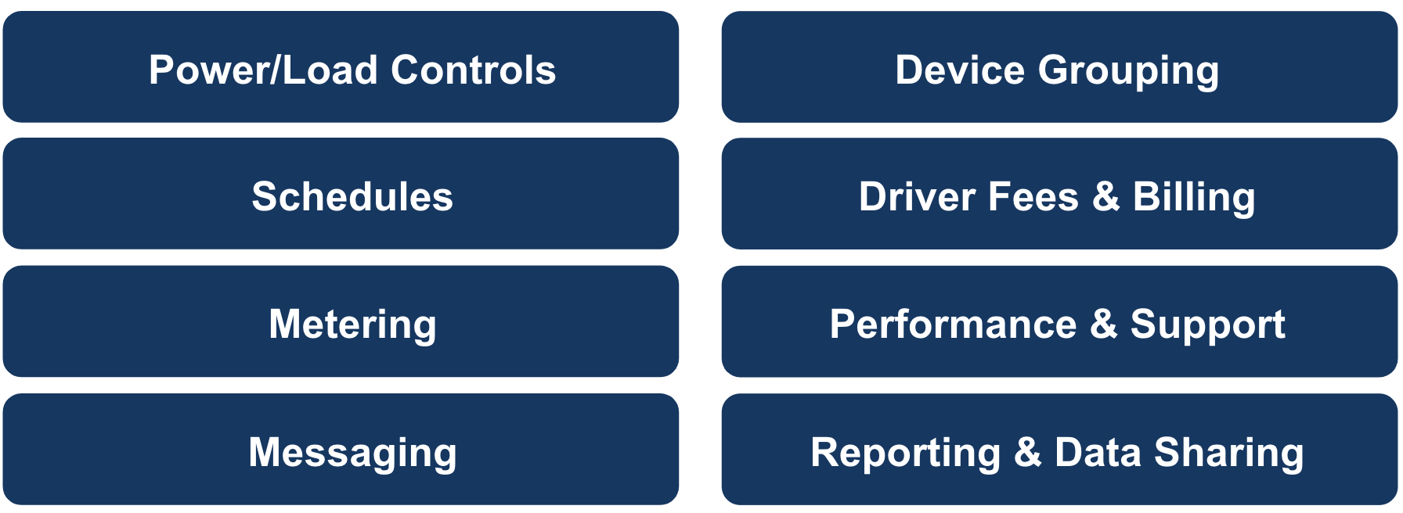

Device Grouping
Using the Grouping Module in ZEFNET, station owners can set up load management in a variety of ways for a variety of purposes. A group could represent the chargers on a circuit, at a site, in a certain program or test group, or an entire portfolio, and groups can be nested. Driver fee or billing profiles as well as data reporting and driver messaging can also be applied at the group level. Lastly, a group of chargers can be overlapped with a schedule, whether this is a driver fee schedule (e.g. higher per minute or per kWh rates at peak times versus off peak times) or a load management schedule.

Load Management & Power Sharing Capabilities
Through the ZEFNET platform, station owners or portfolio managers can manage each device or groups of devices to manage against peak power costs, to avoid demand charges, or to control how chargers utilize on-site energy generation. Specifically, ZEFNET provides granular load management by being able to curtail or ramp the power delivered through any EVSE at a given moment in 25% increments of the nameplate capacity of the charger (e.g. 25% increments of a 11.5kW charger). Within ZEFNET, there are two primary types of load controls:

- Static Balance Controls: This type of control allows an account user to set a constraint for an individual charger or a group of chargers and effectively tells the devices to limit power output against that limitation or constraint.

Example: A constraint could be set that at a site, all the EVSEs and DCFCs on a single meter are not allowed to exceed 200kW at one time. Thus, a static balance control could be used to curtail the power output through some of those chargers so that as more vehicles plug in, the power delivered through each constrained plug would be 75% of nameplate capacity, 50% of nameplate capacity, etc..

- Active Balance Controls: This type of control is used when you have a live data feed that you want to match your EV charging output to, whether managing against a building load, the percentage of power that should come from on site renewables, or what power delivery should look like if a site switches to back-up generation mode.

Example: Data from an eGauge could be used to monitor the power being used by peaking equipment in an office building or retail store (e.g. elevators and pumps). Thus, charger output could be limited to 25%, 50%, or 75% of nameplate capacity depending on the information shared via the data feed.

In addition to these types of controls, they can be overlayed on a schedule set within ZEFNET to have regular, recurring controls. Alternatively the platform can support ad hoc load management, allowing station owners to nearly immediately change power delivery if needed.

Lastly, the ZEFNET allows for ‘power-sharing’ where power can be shared by multiple chargers across a single circuit to maximize power delivery and optimize charging access for more vehicles simultaneously. Power sharing can be applied at the circuit or panel level. This is achieved by assigning the available amperage to a group of chargers. This is in addition to more nuanced dynamic power sharing that can be programmed on some of our modular DC fast charging equipment. Here, even more nuanced controls can be utilized to optimize and distribute power depending on vehicle needs and infrastructure conditions.

C. Driver Fees & Price Schedules
Schedules can not only be applied to load controls, but also to what rates and fees drivers are paying for their charging session or other ancillary benefit, such as parking or dwell times. The station owner or portfolio operator can set fees at the per minute or per kWh level and can attach taxes and a variety of fees. Fees are very flexible and can be configured to be according to street or parking lot cleaning schedules, dwell times or delayed dwell fees, as well as based on seasons and holidays. Beyond full control over fee and price scheduling, ZEFNET allows users to also manage messaging that will be surfaced to the driver via the charger’s screen or via the driver facing app. This allows the station owner to notify drivers that they will be assessed a fee after parking for X amount of time or to even message to drivers when equipment is unavailable for purposes of service or other facility needs.

ZEFNET Time-Based Rate Scheduling Capabilities (example)
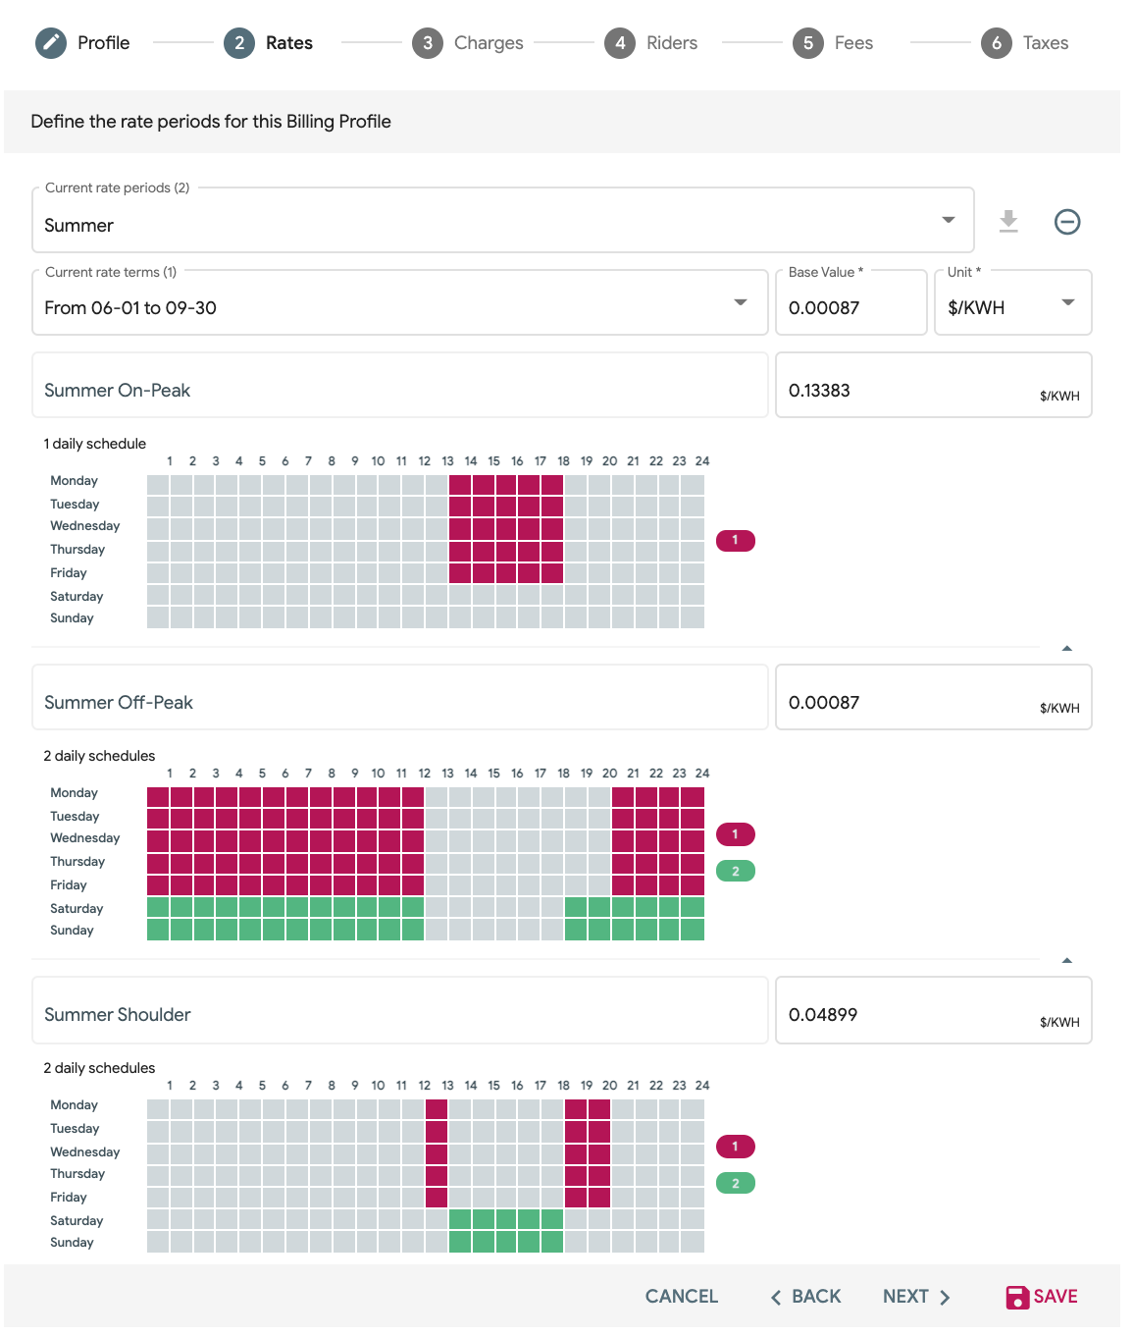

D. Performance & Error Resolution
Within ZEFNET and across multiple ‘modules’, performance metrics are visible to help station owners have clear visibility into how their equipment is performing, and when needed, that they have visibility of equipment issues, open support tickets, or service work orders that might be in progress. ZEF Energy’s own Service & Support Team monitor charger performance on an ongoing basis and are set-up to respond proactively to issues that arise when equipment is under a ZEF Service Level Agreement.

IV. Data Reporting

ZEF is focused on working closely with utility partners and helping them build strong relationships with their customers through new EV charging programs and customer conveniences. As part of this aim, all charging station owners own their own charging equipment data and have access to that data at all times - at no added cost. For this reason, ZEFNET provides extensive data access and reporting to make project learning and regulatory reporting easy.

Station owners have the ability to look at data and to run reports at any time, directly. Easy, ready-made reports include monthly and annual session reports. These reports include total kWh, peak kW, total transaction amount, total number of sessions, and average number of sessions per day – all listed as a total per plug, per site, and/or across multiple sites.

At the device level, ZEF logs detailed information about each charging session. The station owner will also have access to all of this data. This includes, but is not limited to, the information shown in the Exhibit below.

Available Charging Data (via ZEFNET)
Field Name | Information Collected
Serial | Serial number of the charger, as reported by the charger
Initiator | Which partner initiated the session, ZEF, ChargeHub?
Identity | The ID that the billing will be attributed to. For example ZEF User ID, ChargeHub User ID, the ID that the Credit Card Reader shares with the Charger when authorization a charge etc. Note: The Credit Card Reader shares an ID that doesn't change with the charger, and the charger recognizes that this ID is "The Credit Card Reader telling me that I have an authorized user” but is NOT the unique user. The Credit Card Reader does NOT tell the charger WHO swiped the card, simply the fact that someone successfully swiped a card, and is telling the charger to allow a session to start.  This field can be useful identifying the unique users count on a charger, if an app
Start & Stop Time | When a vehicle was plugged in or when the Start button was pressed on an App (not when a car began charging); session end time once electricity stopped flowing
Plug Duration | The total time that a vehicle is plugged in.
Charge Duration | The total time that a vehicle is charging (a.k.a. pulling power).
Energy | Amount of energy used during the session; max kW drawn per session
Cost | Cost of the session (total revenue from the transaction)
Bill Details | If the cost profile has been set up in the Billing module, then a detailed Bill will be available for review. If the cost profile is set up in the normal charger setup window, then the Bill detail will not be populated. Taxes and fees collected are tracked as separate line items for reporting out of ZEFNET and to the customer (per the ZEFNET CHARGE App)
Station Performance | Annual uptime (rolling 12-month basis), annual downtown (rolling 12-month basis), Power derating relative to expected power, internal DCFC unit temperature, quantity of remote restarts provided per the last 12 months and as a % of total charging sessions, error code history.
Connectivity | Cellular strength per station, Current Connectivity Status, Variation in Connectivity over time (last month and year)

In addition to the data listed above, detailed metrics around equipment performance are tracked, as discussed in other sections of this proposal. Easily available downloadable report formats include raw .csv files and ATS files (one meter data management file type used by Meridian). Other exported reports are available via DERMs integrations and beyond.

ZEFNET also supports the sharing of data with partners when projects call for this capability. This might include a variety of utility customers that have interest in energy consumption or charging session counts by time of day. ZEFNET Connect is a module within ZEFNET that makes partner data sharing easy and allows for detailed permissions settings. Data can be shared in a ‘view only’ mode or view some data while offering functionality in specific areas of the portal. This is highly configurable for the customer/station owner.

V. Maximum Data Accessibility

ZEF Energy is focused on working closely with utility partners and helping them build strong relationships with their customers through new EV charging programs and customer conveniences. As part of this aim, ZEF Energy believes that our customers should own their own charging equipment data and have access to that data at all times, at no added cost. For this reason, ZEFNET provides extensive data access and reporting to make project learning and regulatory reporting easy.

Further, ZEFNET supports the sharing of data with partners when projects call for this capability. This might include a variety of utility customers that have interest in energy consumption or charging session counts by time of day. ZEFNET Connect is a module within ZEFNET that makes partner data sharing easy and allows for detailed permissions settings.

MERCHANT COMPENSATION & FUNCTIONALITY

Section 4 | Payment to Station Owners & Driver Fee Setting
ZEFNET charging stations offer the following payment options for drivers:
- Credit cards, via a credit card reader
- A ZEFNET RFID card you can request when setting up an account
- The ZEFNET mobile app, which links to your driver account
- Charger RFID reader is NFC enabled – allows for payment via apple pay, google pay, etc.
- A roaming partners mobile app, i.e., ChargePoint.
The only added fee to MLGW is the monthly 10% fee that is held back from the charging station revenue, which covers the processing of all payments. There are no additional fees to drivers, unless that is something MLGW wanted to institute.

Driver Payment Options
Each charging satellite will have one credit card and RFID reader (with NFC technology as well) installed – effectively one credit card reader + RFID reader per two (2) plugs. This will allow all drivers the ability to pay for a charging session by credit card, RFID, NFC payment (e.g. Apple Pay or Google Pay) or via app (the ZEFNET Charge App or another app with a roaming agreement such as ChargePoint). This set-up also provides a high ratio of credit card readers to plugs, so that drivers don’t have to stand in line at a central payment kiosk before starting their charge.

Most EV drivers currently pay as “walk-up” customers and the software, app, and hardware is set-up to accommodate this and offer a smoother driver experience. ZEF does also offer a ZEFNET network subscription. This can be accomplished through a PIN that is shared with them and then used via the app or through the distribution of a ZEF RFID card.

Driver Payment Experience
Drivers have the ability to pay via more than six (6) methods.
- Multiple Methods at the Charger: Credit card via a credit card reader on each DCFC satellite where there is (1) credit card reader per (1) or (2) plugs. This reader also takes payment via NFC (e.g. Apple Pay or Google Pay) and from a ZEFNET provided RFID card.
- Multiple App Options: ZEFNET CHARGE App or other apps that belong to the networks or map aggregators that ZEF Energy has roaming agreements with. This includes ChargeHub, ChargePoint, SemaConnect, Mercedes and others. This list continues to grow every 6 months as part of our expanding OCPI efforts.
- Via Charge Network Membership: As a member you can either receive an RFID card, authenticate via your email address, or via a provided PIN. The RFID card would be used on the RFID reader, the others would be used in the ZEFNET CHARGE App.

The payment process on the ZEFNET CHARGE App is easy for drivers. The following images walk through the steps of the transaction process.

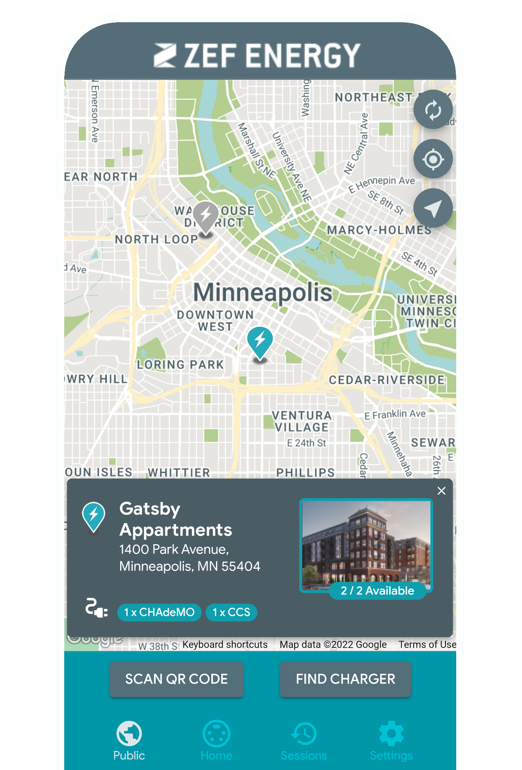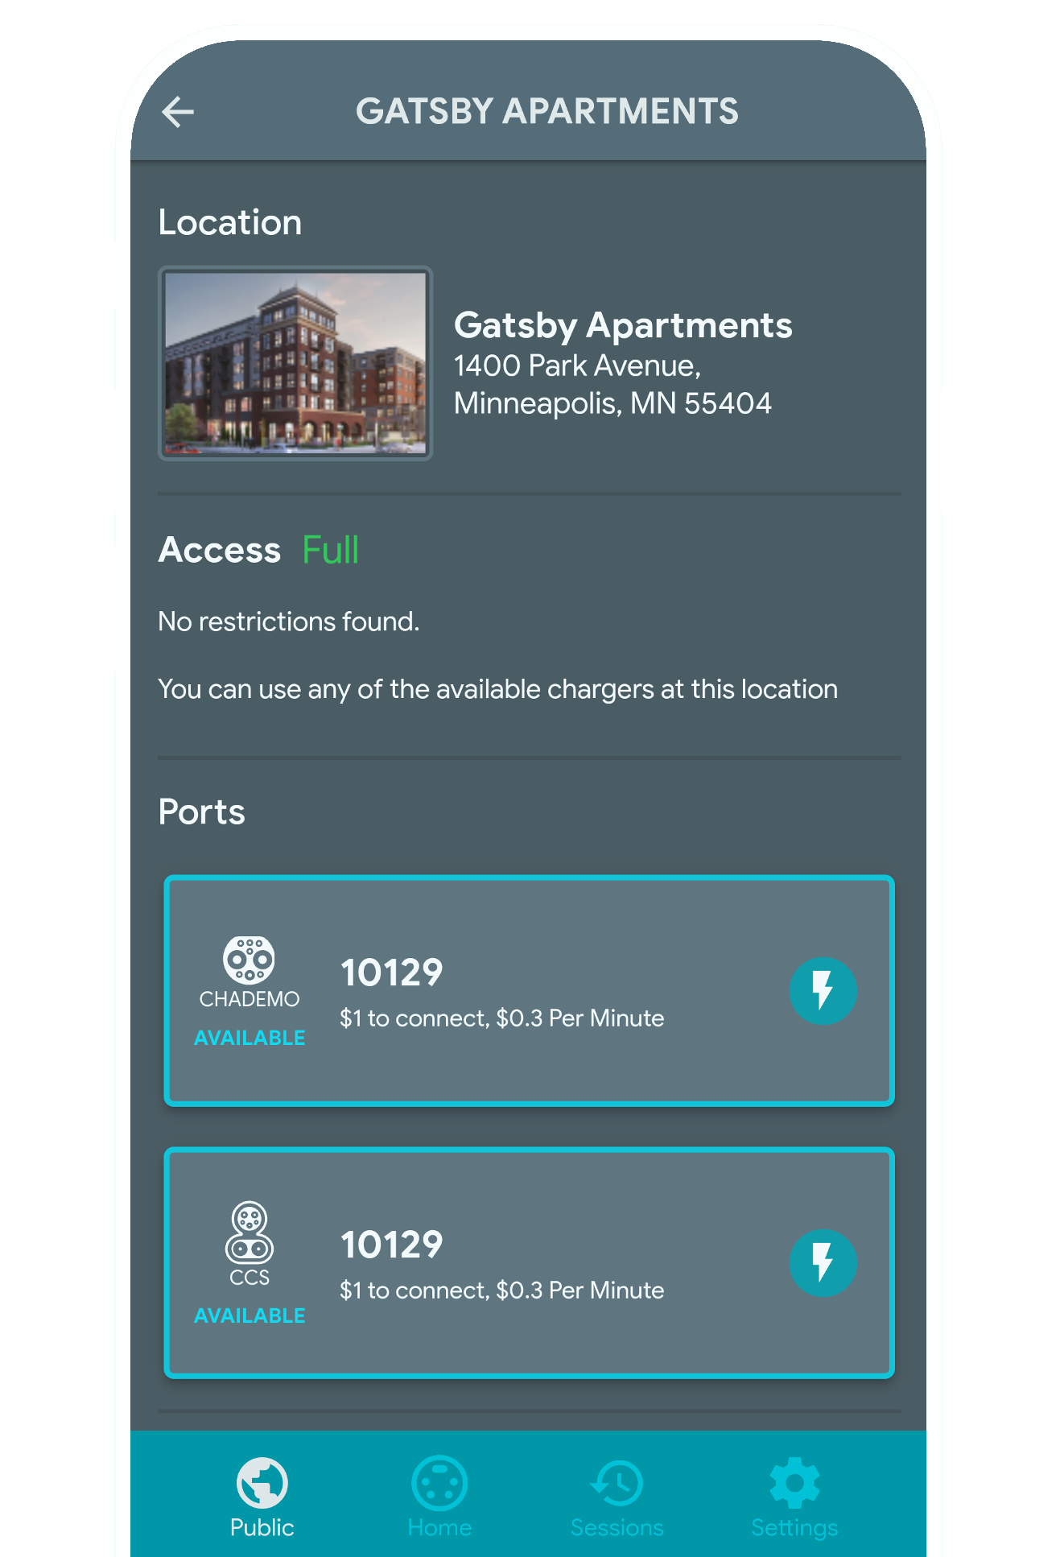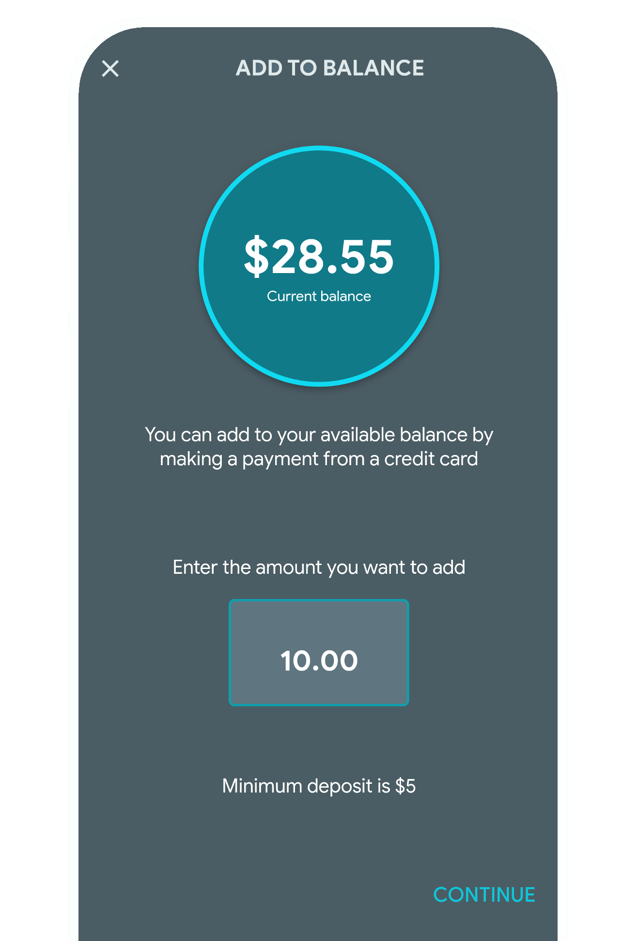

#1 Find your charger via map, #2 Choose your plug #3 Add money to your wallet
by charger ID number or by if applicable. If not enough stored already.
QR code.

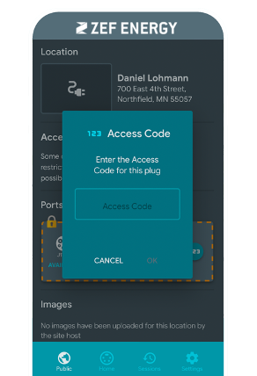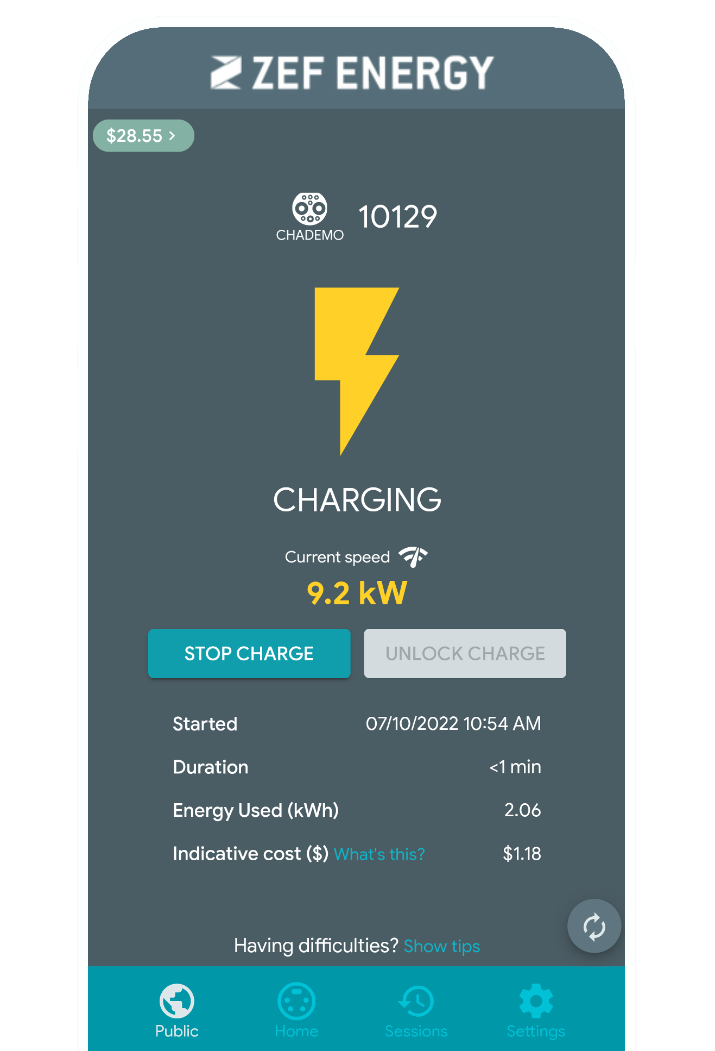

#4 Enter your PIN code if that #5 Press the Start Charge
Is the chosen method for button on the DCFC screen
Authentication (e.g. for network or on the App. Then see
members or those with different real time charging session data.
pricing)

At any time, station owners (with the support of ZEF’s Support Team as needed) can change the PIN number or email addresses (e.g. for fleet or authorized drivers) that can have access to the chargers. This is done in the ZEFNET network portal online.
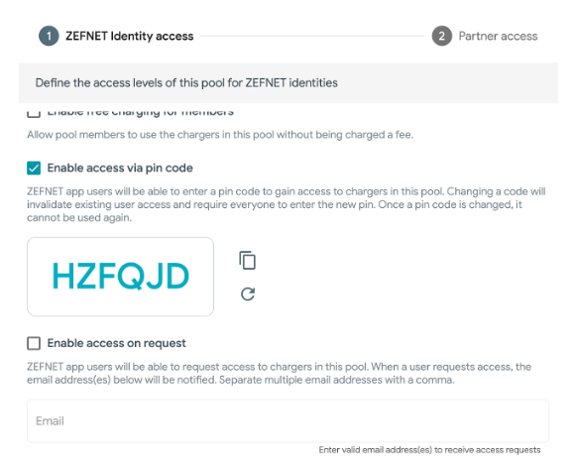
Pricing is displayed to the driver in the ZEFNET CHARGE App, other ops that ZEFNET has interoperability with, as well as on the screen of each of our Level 2 and DCFC charging units. Here, the pricing will be displayed per how it has been set-up in the ZEFNET backend, either as a per minute rate or a per kWh rate. Dwell fees will also be shown on the screen at the time the driver plugs in and right before a dwell fee is about to be applied.
If other charges are applied, such as tax, that will be applied at the end of the session and seen on screen and in the app as part of the total cost of the transaction. For a detailed overview of the taxes or fees that might have been applied to the charging session, these are visible on the ZEFNET CHARGE app “Transaction” history screen.

Compensation / Remittance Process
For charging stations that will take payment to operate (e.g. Level 2 and DCFC public stations, semi-private or secure stations at workplaces, etc.) ZEF will remit (pay forward) revenues received from drivers to the station owner or payee of the electric bill. The amount remitted will be the total amount of the payments taken from drivers minus a 10% transaction fee (a standard transaction fee) to cover credit card transaction fees. This arrangement (per the terms of the Compensation Agreement attached) will be initiated once a station has completed commissioning. Before payments can be remitted, the station owner will have to set-up an account in Bill.com, the platform we use for remittance. Remittance will occur on a monthly basis by default unless the station owner prefers a frequency of every other month or quarterly.

During the onboarding process, ZEF will work with the station owner (client) to set-up to enable monthly payments to happen immediately and easily upon the station “going live.”

